<https://public.tableau.com/profile/venkata.daya.sagar.ketaraju#!/vizhome/Accesstowaterandsanitation_16191622127190/Accesstowaterandsanitation?publish=yes>

link

Screen shot#1

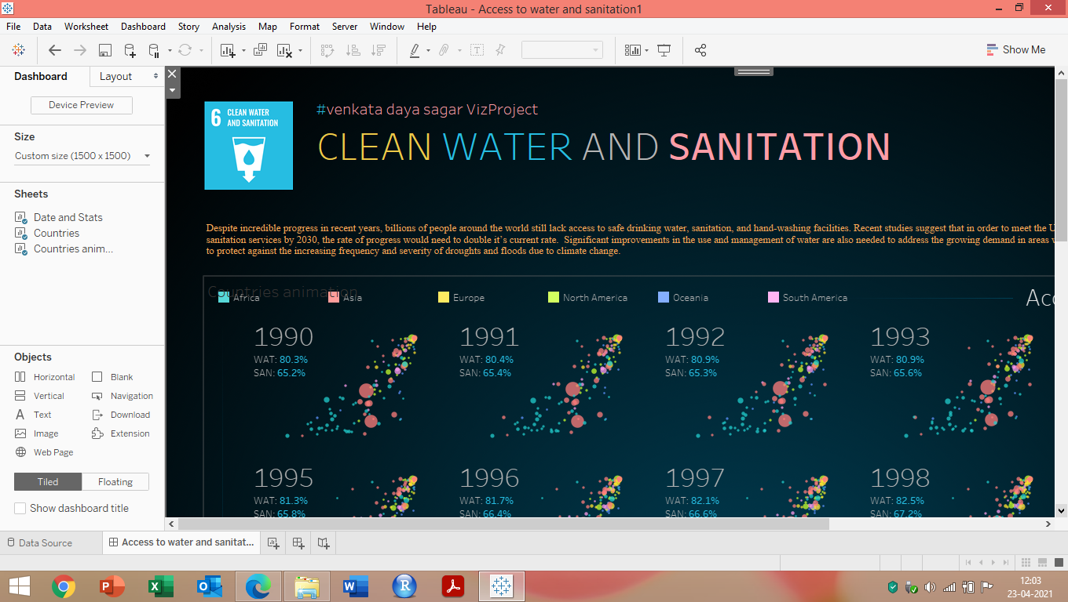

Screen shot#2

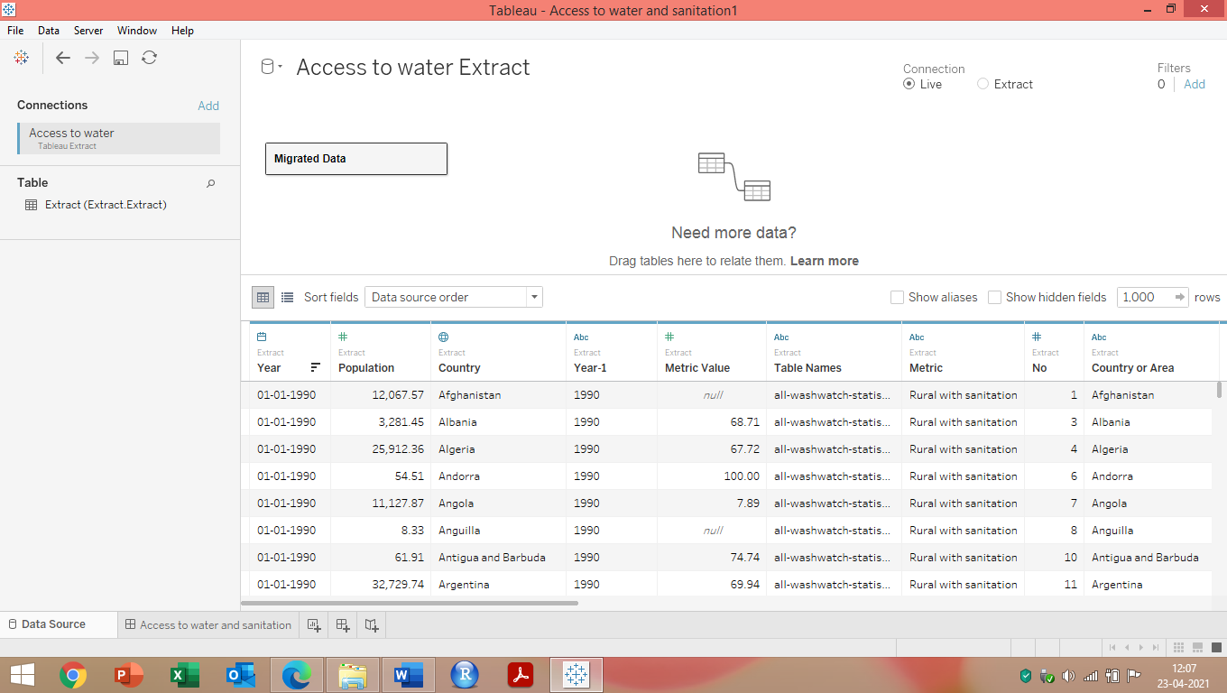

Screen shot#3

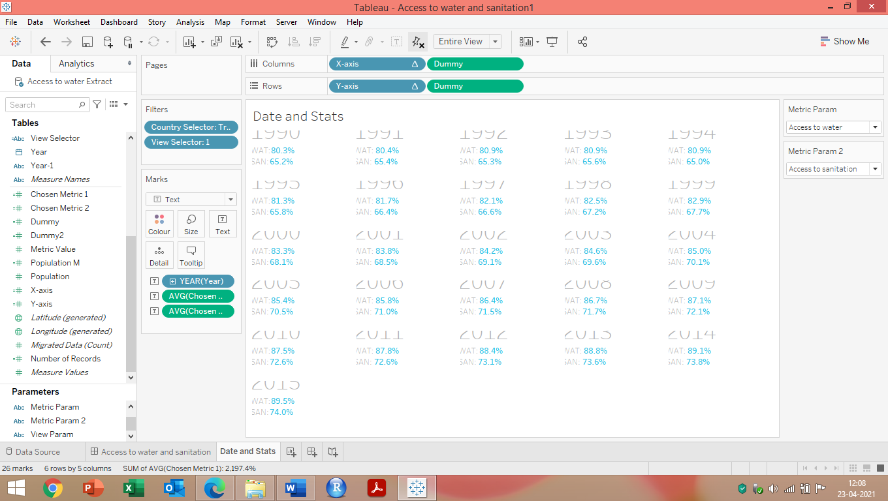

Screen shot#4

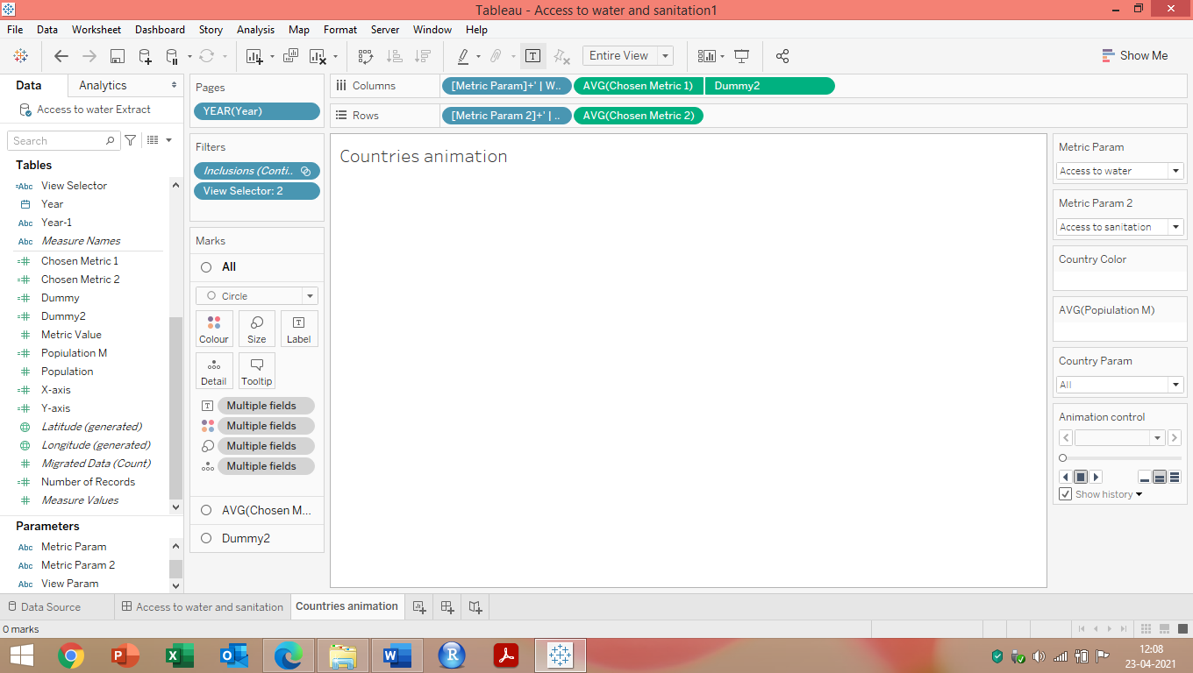

Screen shot#5

